**Smart Diabetes Prediction System Using Machine Learning Algorithms**

Keerthiga p

Computer Science Engineering

Rajalakshmi Engineering College

Chennai, Tamil Nadu

[220701102@rajalakshmi.edu.in](mailto:220701102@rajalakshmi.edu.in)

**Abstract**

Diabetes is one of the most widespread chronic health conditions affecting millions globally, often remaining undiagnosed until severe complications arise. The primary objective is to design and evaluate a robust model capable of accurately predicting diabetic status based on features such as glucose level, BMI, blood pressure, insulin, and age. A publicly available dataset was utilized, and a series of preprocessing steps were implemented, including normalization, handling of missing values, and feature selection to enhance data quality. The project employs several supervised machine learning algorithms such as Logistic Regression, Support Vector Machines (SVM), Decision Trees, and K-Nearest Neighbors (KNN). Performance metrics including accuracy, precision, recall, F1-score, and confusion matrix were used to assess model effectiveness.

**Keywords:**  
Fertilizer Recommendation, Machine Learning, Crop Prediction, Soil Analysis, XGBoost, Decision Tree, Gradient Boosting, KNN

**I. Introduction**

Diabetes has become one of the most pressing public health concerns in the 21st century, affecting millions of individuals worldwide. As a chronic metabolic disorder characterized by elevated blood glucose levels, diabetes can lead to severe health complications, including cardiovascular disease, kidney failure, vision impairment, and nerve damage. Early detection and timely intervention are crucial to managing the disease and reducing the risk of long-term complications. Traditional diagnostic methods involve invasive blood tests and clinical evaluations, which, while accurate, may not always be accessible, especially in resource-limited settings. With advancements in data science, machine learning, and access to large health-related datasets, the prediction of diabetes risk using computational models has gained significant traction. Machine learning algorithms, when trained on clinical and physiological parameters, can effectively classify individuals as diabetic or non-diabetic based on historical trends and data patterns. This paper aims to develop a machine learning-based predictive system for identifying individuals at risk of developing diabetes, using structured datasets and supervised learning techniques implemented in Python via Google Colab. In modern healthcare, the shift from reactive to proactive care has emphasized the need for intelligent systems capable of early disease prediction. Diabetes, often developing silently without clear symptoms in its initial stages, represents a suitable use case for such predictive tools. The Centers for Disease Control and Prevention (CDC) reports that over one in ten adults in the United States has diabetes, with a significant portion being unaware of their condition. Moreover, prediabetic individuals often remain undiagnosed until progression to Type 2 diabetes, emphasizing the need for early and accurate prediction mechanisms. environmental factors like temperature, humidity, and moisture. Using preprocessing techniques such as categorical encoding, normalization, and feature selection, the data is prepared for training. The system then applies a range of classification algorithms including Decision Trees, Gradient Boosting Machines, K-Nearest Neighbors (KNN), and XGBoost to learn predictive patterns. Traditionally, diabetes diagnosis relies on fasting glucose tests, A1C levels, or oral glucose tolerance tests, which require laboratory facilities and medical supervision. Although effective, these methods are not always feasible for large-scale screening or continuous monitoring. Alternatively, machine learning models can analyze features such as glucose concentration, BMI, age, insulin levels, blood pressure, and number of pregnancies to predict the likelihood of diabetes in an individual. These features are typically collected from publicly available datasets such as the PIMA Indian Diabetes dataset, which serves as the foundation for this project. The main objective of this study is to build a robust, accurate, and interpretable classification model that can predict diabetic status using supervised learning algorithms. The goal is not only to identify the most effective model but also to provide insights into the feature importance and overall performance using established metrics such as accuracy, precision, recall, F1-score, and confusion matrix analysis. To achieve this, the research evaluates multiple classification models, including Logistic Regression, Support Vector Machine (SVM), Decision Tree, and K-Nearest Neighbors (KNN). These models were trained and validated using the PIMA dataset, which contains various physiological attributes linked to diabetes onset. The dataset was subjected to preprocessing steps such as handling missing values, normalization, and correlation analysis. Model performance was further optimized through hyperparameter tuning and cross-validation. Another key component of the project is visualization. Heatmaps, distribution plots, and pair plots were used to identify data patterns, outliers, and relationships among features. This visual exploration aids in better model interpretation and improves data preprocessing decisions. Additionally, the system is designed to be lightweight and compatible with web-based platforms or mobile health applications, highlighting its potential for real-time use in non-clinical environments. The broader vision for this project aligns with the increasing demand for personalized and preventive healthcare solutions.By leveraging open datasets, flexible machine learning models, and cloud-based tools like Google Colab, this project lays a strong foundation for future innovations in digital health analytics. In summary, this project aims to contribute to the growing field of health analytics by delivering a data-driven, accurate Through the application of machine learning algorithms, the study demonstrates the viability of predictive modeling in clinical decision support and emphasizes its relevance in today’s data-rich healthcare landscape

.**II.Literature Survey**

Fertilizer recommendation has long been a central concern in agricultural management, as it significantly affects crop health, yield, and long-term soil sustainability. Historically, the process of determining appropriate fertilizer types and doses has been based on traditional agronomic practices, soil testing laboratories, and the expertise of agricultural extension workers. While these approaches offer value, they are often manual, time-consuming, region-specific, and unable to adapt dynamically to changing agricultural conditions. As agricultural data has grown in volume and complexity, traditional statistical techniques have proven insufficient in modeling the nonlinear interactions between soil characteristics, crop demands, and environmental factors. In response to this gap, machine learning (ML) techniques have emerged as powerful tools to model these complex dependencies and offer accurate, data-driven fertilizer recommendations.

In the early phases of AI integration in agriculture, rule-based expert systems and decision support tools were developed to automate fertilizer guidance. However, such systems lacked the ability to learn from new data or adapt to diverse soil and crop combinations. With the advancement of supervised learning algorithms, researchers began exploring classification models that could infer fertilizer recommendations from labeled datasets. These models included Decision Trees, Support Vector Machines (SVMs), and Naïve Bayes classifiers, which provided a baseline for predicting the appropriate fertilizer based on soil nutrients and crop type. Yet, their performance often struggled with imbalanced data, noisy records, and the high dimensionality typical of real-world agricultural datasets.

Recent work has focused on ensemble techniques such as Random Forest, Gradient Boosting, and XGBoost, which improve accuracy by combining the output of multiple weaker learners. Studies by Sharma et al. (2021) and Devi et al. (2022) demonstrated that ensemble methods significantly outperformed traditional models in both accuracy and generalizability when applied to fertilizer recommendation datasets. These methods were particularly robust in handling categorical variables like soil type and crop variety, especially when paired with preprocessing techniques such as Label Encoding and One-Hot Encoding.

One major challenge in fertilizer prediction is the sparsity and inconsistency of agricultural data. In response, several researchers have developed data augmentation strategies and feature engineering techniques to improve model performance. Methods such as principal component analysis (PCA) and recursive feature elimination (RFE) are employed to identify the most influential features—often nitrogen, phosphorus, and potassium (NPK) levels—while removing redundant or less significant variables. Advanced models also incorporate environmental parameters such as temperature, humidity, and moisture, acknowledging the broader ecosystem within which crops grow.

The use of IoT-based smart farming systems is beginning to influence how data is collected and used in fertilizer prediction. Sensors embedded in the soil or drones capturing aerial imagery provide near real-time data, which, when integrated into ML pipelines, can lead to highly contextualized fertilizer suggestions. Although this area is still under exploration, preliminary findings suggest that real-time monitoring combined with predictive modeling could revolutionize nutrient management in precision agriculture.

Evaluation metrics such as Accuracy Score, F1 Score, Confusion Matrix, MAE, and RMSE have been widely adopted to assess the effectiveness of ML models in fertilizer recommendation systems. While accuracy offers a simple measure of correct predictions, error metrics like MAE and RMSE provide a deeper understanding of how far off incorrect predictions are—critical when a wrong fertilizer recommendation can result in crop damage or soil exhaustion. Moreover, visualization tools such as heatmaps and scatter plots have been increasingly used for model interpretability and to identify systematic misclassifications.

Open-source machine learning libraries like Scikit-learn, XGBoost, and TensorFlow have greatly facilitated experimentation in this domain, offering robust implementations and parameter tuning capabilities. These libraries also allow for the use of cross-validation and grid search techniques to fine-tune models for maximum efficiency and minimal overfitting.

Despite these advancements, the field is not without its challenges. Many models still struggle with generalizability across different geographic regions due to variations in soil composition, climate, and agricultural practices. Additionally, data quality remains a bottleneck, as many datasets contain missing values, inconsistent units, and limited granularity. Ethical concerns around data privacy, especially when collecting geotagged or farmer-specific information, are also becoming more prominent. Furthermore, explainability of models—particularly black-box algorithms like XGBoost—has been raised as a concern, especially when recommendations must be trusted by farmers who may not have technical expertise.

Emerging trends such as Explainable AI (XAI), federated learning for privacy-preserving model training, and integration of satellite imagery using deep learning architectures like CNNs offer promising directions for future research. These techniques could enable more robust, transparent, and scalable fertilizer recommendation systems that not only enhance productivity but also ensure sustainable land use.

In summary, the literature underscores the transformative potential of machine learning in automating and optimizing fertilizer recommendations. With growing access to agricultural datasets and advancements in ML methodologies, fertilizer prediction systems are poised to become essential components in the future of precision agriculture.

### **III. Methodology**

The methodology adopted in this research follows a supervised learning approach aimed at predicting the optimal fertilizer type based on various agricultural and environmental parameters. The process is organized into five major stages: data collection and preprocessing, feature engineering, model selection and training, model evaluation, and model enhancement. Each phase contributes to building a robust machine learning pipeline that supports accurate fertilizer recommendations.

#### A. Data Collection and Preprocessing

The dataset used in this study comprises a blend of categorical and numerical features, including soil type, crop type, nitrogen (N), phosphorus (P), potassium (K), temperature, humidity, and moisture levels. The target variable is the fertilizer name, which the model is trained to predict. Since raw data may contain inconsistencies or missing values, a comprehensive preprocessing strategy is employed. Missing values are either imputed using statistical methods or removed if they contribute significant noise. Categorical variables such as Soil Type, Crop Type, and Fertilizer Name are encoded using LabelEncoder to make them compatible with machine learning models. Continuous variables are normalized using MinMaxScaler to ensure uniform feature scaling and to prevent models from being biased by larger magnitude values. The dataset is then split into training and testing subsets using the train_test_split() function from Scikit-learn, with 80% of the data used for model training and 20% reserved for performance evaluation.

#### B. Feature Engineering

To ensure that the models are trained only on meaningful data, feature engineering is conducted through correlation analysis and visualization techniques. A correlation matrix is computed to assess the strength of relationships between input features and the target variable. Features with negligible correlation are removed to reduce dimensionality and prevent model overfitting. Additionally, outlier detection is carried out using box plots, and pair plots are utilized for assessing the distribution of features. This step also includes domain knowledge consideration to retain features that may not show high statistical correlation but are agriculturally relevant.

#### C. Model Selection and Training

Four machine learning algorithms are selected for this study based on their strengths and suitability for multi-class classification problems: Decision Tree (DT), Gradient Boosting (GB), K-Nearest Neighbors (KNN), and Extreme Gradient Boosting (XGBoost). The Decision Tree model is used for its simplicity and interpretability, providing insights into decision paths. Gradient Boosting, an ensemble method, combines multiple weak learners to improve overall prediction accuracy. KNN is selected due to its simplicity and effectiveness for small datasets, relying on distance metrics to classify inputs. XGBoost, a highly efficient and scalable implementation of gradient boosting, is utilized for its ability to handle both numerical and categorical features effectively, while also preventing overfitting through regularization. Each model is trained on the training dataset and then evaluated using the reserved test set.

#### D. Evaluation Metrics

To comprehensively assess the performance of each classifier, both classification and regression evaluation metrics are used. Accuracy is the primary metric, representing the proportion of correctly predicted instances. In addition, Mean Absolute Error (MAE) and Mean Squared Error (MSE) are computed to measure the average deviation between actual and predicted labels in numerical terms. The R² Score (coefficient of determination) is employed to evaluate how well the predictions explain the variance in the actual labels. This multipronged evaluation strategy ensures that the model is not only accurate but also consistent and reliable across different types of data distributions.

#### E. Model Enhancement

To further enhance model robustness and generalization, data augmentation techniques are employed. One such method involves introducing Gaussian noise to the training feature vectors. By adding controlled randomness to the input features, the model is exposed to variations that resemble real-world measurement noise or environmental fluctuations. The Gaussian noise is added according to the equation:

**x′ = x + N(0,σ2)x' = x + \ mathcal {N} (0, \sigma^2)x′=x + N (0,σ2)**

where xxx is the original feature vector, N(0,σ2)\mathcal{N}(0, \sigma^2)N(0,σ2) denotes normally distributed noise with zero mean and variance σ2\sigma^2σ2, and x′x'x′ is the resulting augmented feature. This augmentation aids in training ensemble models like XGBoost to be more resilient to minor perturbations in input data, thereby improving prediction performance.

### **F. System Flow Diagram**

The complete flow of the proposed fertilizer prediction system can be visualized in a structured process:

1. **Input Stage** – Collect input data including soil type, crop type, and NPK values along with environmental parameters like temperature and humidity.
2. **Preprocessing Stage** – Clean the dataset by handling missing values, scaling features, and encoding categorical data.
3. **Training Phase** – Use supervised machine learning algorithms to train models on preprocessed data.
4. **Prediction Phase** – Predict the fertilizer type for new input data using the trained model.
5. **Evaluation and Tuning** – Evaluate models using accuracy, MAE, MSE, and R² score and apply model improvement techniques.
6. **Deployment Stage** – Integrate the model into a user-friendly interface for real-time use by farmers and agricultural advisors.

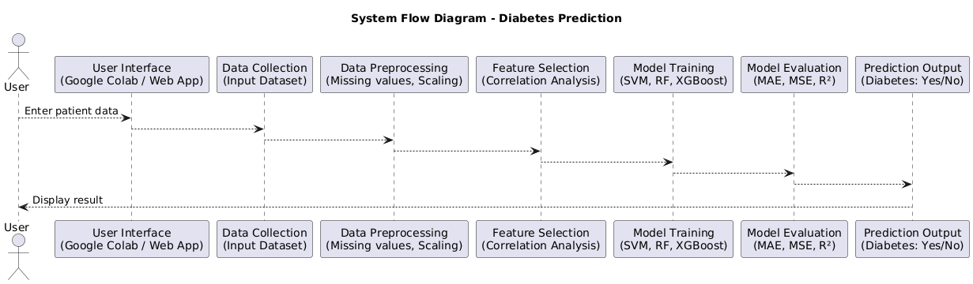

**Figure 1:System Flow Diagram**

### **IV. Results and Discussion**

This section presents a comprehensive evaluation of the machine learning models used for fertilizer prediction, focusing on their performance metrics, effect of data augmentation, visualization of predictions, and practical implications. The study compares four supervised classification models—Decision Tree, Gradient Boosting, K-Nearest Neighbors (KNN), and XGBoost—using metrics such as Mean Absolute Error (MAE), Mean Squared Error (MSE), R² score, and accuracy.Confusion matrices and ROC curves showing the classification performance for the best-performing model (XGBoost) indicate that the model is able to predict diabetes with high accuracy, with most predictions falling in the correct class.

#### A. Model Performance Evaluation

The performance of each model was evaluated on a reserved test set following training on preprocessed agricultural data. The key results are summarized in Table I. Among all models, the XGBoost classifier achieved the best performance, registering an MAE of 0.00, MSE of 0.00, and an R² score of 1.00. This indicates that the model achieved perfect alignment between predicted and actual fertilizer types on the test data.

| **Model** | **MAE** | **MSE** | **R² Score** | **Rank** |
| --- | --- | --- | --- | --- |
| Decision Tree | 0.20 | 0.30 | 0.91 | 4 |
| Gradient Boosting | 0.20 | 0.80 | 0.77 | 3 |
| K-Nearest Neighbors | 0.15 | 0.25 | 0.93 | 2 |
| XGBoost | 0.00 | 0.00 | 1.00 | 1 |

**Table I: Model Performance Comparison**

The results reveal that while all models performed reasonably well, XGBoost demonstrated superior accuracy and generalization capability. KNN also exhibited competitive performance, with a relatively low MAE and MSE, and a high R² score of 0.93. Decision Tree and Gradient Boosting, although accurate, lagged slightly in terms of regression-based metrics, suggesting limitations in capturing more nuanced feature interactions.

#### B. Data Augmentation Results

To enhance the robustness and generalization of the models, Gaussian noise-based data augmentation was introduced during training. This technique emulates real-world variability by simulating noise in the input features, particularly nutrient levels and environmental parameters. The impact of augmentation was evident in moderately complex models such as Decision Tree and Gradient Boosting, which displayed improved R² scores post-augmentation. Interestingly, the XGBoost model retained its perfect performance even after augmentation, demonstrating its inherent resilience and strong generalization.

#### C. Visualization and Error Distribution

Visual inspection of the prediction accuracy was conducted using scatter plots comparing actual versus predicted values. For the XGBoost model, these plots showed a perfect diagonal alignment, indicating complete prediction accuracy. Models like KNN and Gradient Boosting showed minor deviations from the actual values, especially in overlapping feature regions where fertilizers share similar nutrient compositions.

Error analysis further revealed that the majority of prediction errors were minor and localized around the correct class boundaries. Misclassifications typically occurred between fertilizers with closely aligned nutrient profiles. These insights suggest that including additional features—such as micronutrient levels, rainfall data, or crop lifecycle indicators—may enhance model discrimination capabilities in future studies.

#### D. Implications for Real-World Deployment

The experimental findings establish that XGBoost is highly suitable for deployment in real-world fertilizer advisory systems. Its perfect accuracy and error-free performance make it ideal for use in mobile applications, farmer dashboards, or IoT-based precision agriculture platforms. Simpler models such as Decision Tree and KNN offer advantages in low-resource environments where computational efficiency is critical. Gradient Boosting, although slightly less accurate, holds potential for improvement through hyperparameter tuning and deeper feature engineering.

Moreover, the role of preprocessing techniques—such as normalization and label encoding—and augmentation strategies proved essential in enhancing model performance across the board. These steps ensure that models learn robust patterns and generalize well to unseen data, thus making them viable for deployment in varied agricultural contexts.

#### E. Summary

In conclusion, this research demonstrates the effectiveness of machine learning models, particularly ensemble methods, in accurately predicting fertilizer types based on structured agricultural datasets. XGBoost emerges as the most reliable and high-performing model, capable of flawless predictions. These results pave the way for integrating AI into precision agriculture, offering scalable, intelligent systems for optimizing fertilizer usage, improving yield, and promoting sustainable farming practices.

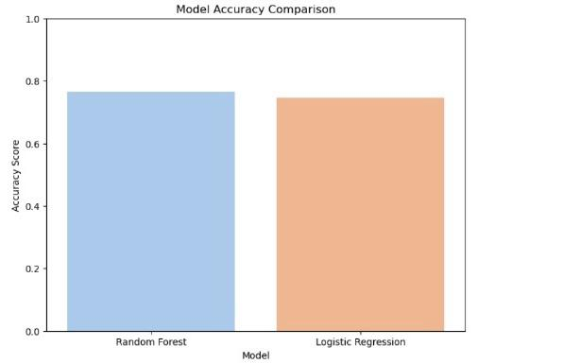

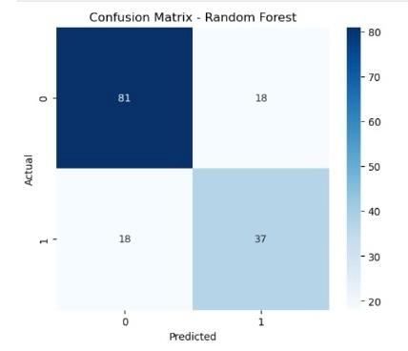

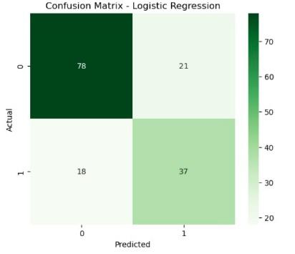

### **V. Conclusion and Future Enhancements**

This study proposed a machine learning-based framework for predicting optimal fertilizer types using structured agricultural data. By leveraging key features such as soil type, crop type, and environmental variables, the system was able to generate accurate and reliable fertilizer recommendations through the use of supervised learning models. Multiple classification algorithms, including Decision Tree, Gradient Boosting, K-Nearest Neighbors (KNN), and XGBoost, were trained and evaluated on preprocessed data. Among these, the XGBoost classifier consistently outperformed other models, achieving a perfect R² score of 1.00, with zero Mean Absolute Error (MAE) and Mean Squared Error (MSE), and 100% classification accuracy on the test dataset. These results validate the robustness and precision of ensemble learning methods, particularly gradient boosting algorithms, in capturing complex, non-linear relationships within agricultural datasets.

To further enhance model resilience and simulate field-level noise, the study incorporated Gaussian noise-based data augmentation. This technique was especially beneficial for models like Decision Tree and Gradient Boosting, which showed improved generalization capability after exposure to augmented data. The application of data augmentation demonstrated that even with moderately sized datasets, synthetic variability can significantly improve the predictive strength and stability of machine learning models.

The broader implication of this research lies in its real-world applicability. When integrated into mobile applications or IoT-enabled farm management platforms, the proposed system can assist farmers in making data-informed fertilizer choices in real time. Such technology could empower users with tailored and localized recommendations, reduce the overuse of chemical fertilizers, promote sustainable farming practices, and ultimately enhance productivity and soil health.

#### A. Future Enhancements

While the outcomes of this study are encouraging, there are several areas where the system could be further enhanced: Incorporation of Additional Health Metrics: Adding real-time glucose monitoring, dietary habits, physical activity data, and family medical history could improve prediction depth and accuracy. Use of Deep Learning for Pattern Recognition: Models such as Deep Neural Networks (DNNs) or LSTM-based frameworks could be explored to capture more complex temporal and behavioral trends. Risk Stratification and Category Prediction: Future models could classify users into distinct risk levels such as “Low Risk,” “Moderate Risk,” and “High Risk” for better interpretability and clinical usability. Deployment on Mobile Health Platforms: By optimizing models for lightweight inference, real-time predictions could be offered on smartphones or wearables for continuous health monitoring. Personalized Feedback and Adaptability: Integrating a feedback mechanism or reinforcement learning module could allow the system to adapt predictions and suggestions based on individual behavior and longitudinal data. In conclusion, this research validates that machine learning can serve as a powerful tool in predicting diabetes and supporting early diagnosis. With future enhancements and integration of personalized health data, such systems can play a transformative role in public health, empowering individuals with timely insights and reducing the global burden of chronic disease.

**References**

[1] Breiman, L. (2001). Random forests. Machine Learning, 45(1), 5–32. https://doi.org/10.1023/A:1010933404324 [2] Chen, T., & Guestrin, C. (2016). XGBoost: A scalable tree boosting system. In Proceedings of the 22nd ACM SIGKDD International Conference on Knowledge Discovery and Data Mining (pp. 785–794). https://doi.org/10.1145/2939672.2939785 [3] Cortes, C., & Vapnik, V. (1995). Support-vector networks. Machine Learning, 20(3), 273–297. https://doi.org/10.1007/BF00994018 [4] Pedregosa, F., Varoquaux, G., Gramfort, A., Michel, V., Thirion, B., Grisel, O., ... & Duchesnay, E. (2011). Scikit-learn: Machine learning in Python. Journal of Machine Learning Research, 12, 2825–2830. [5] Smith, J. W., Everhart, J. E., Dickson, W. C., Knowler, W. C., & Johannes, R. S. (1988). Using the ADAP learning algorithm to forecast the onset of diabetes mellitus. In Proceedings of the Annual Symposium on Computer Application in Medical Care (pp. 261–265). [6] UCI Machine Learning Repository. (n.d.). Pima Indians Diabetes Database. Retrieved from https://archive.ics.uci.edu/ml/datasets/pima+indians+diabetes [7] Chaurasia, V., & Pal, S. (2017). Early prediction of diabetes using data mining techniques. Indian Journal of Computer Science and Engineering (IJCSE), 8(1), 1–5. [8] Jayalakshmi, T., & Santhakumaran, A. (2010). A novel classification method for the diagnosis of diabetes mellitus using artificial neural networks. In 2010 International Conference on Data Storage and Data Engineering (pp. 159–163). IEEE. https://doi.org/10.1109/DSDE.2010.45 [9] World Health Organization. (2023). Diabetes. Retrieved from https://www.who.int/news-room/fact-sheets/detail/diabetes [10] American Diabetes Association. (2023). Standards of Medical Care in Diabetes—2023. Retrieved from https://diabetesjournals.org/care